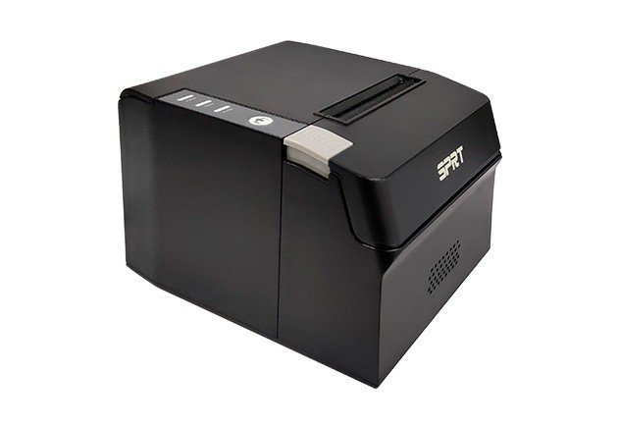 

* **Modern Sleek Design**
* **Small footage to suit to save space**
* **Design for Business**
* **Durable and affordable**
* **Simple design, easy to use, user friendly**
* **USB + Ethernet Port**

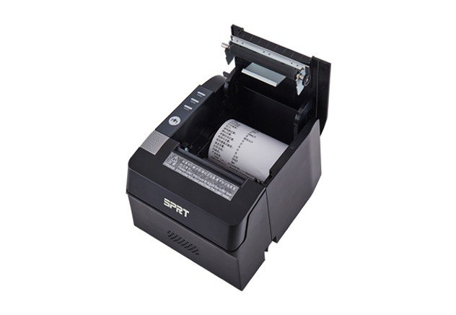

Driver: Windows 98 / ME / 2000 / NT / XP / 2003 Server/Vista/Win7/Win 8,8.1/Linux/OPOS



c

|  |  |  |  |
| --- | --- | --- | --- |
| **Print** | **Printing Method** | | **Thermal Line** |
| **Printing Speed** | | **200mm/s** |
| **Resolution** | | **8 dots/mm, 576 dots/line. 203DPI** |
| **Effective Printing Width** | | **72mm** |
| **Character** | **Character Set** | | **ASCII, GB18030(Chinese),BIG5** |
| **Print Font** | | **Codepage, ANK: 12 x24; Chinese: 24 x 24** |
| **Character per Line** | | **42/48** |
| **Paper Spec** | **Paper Type** | | **Thermal paper** |
| **Paper Width** | | **79.5± 0.5mm** |
| **Paper Roll Diameter** | | **Max: 80.0mm** |
| **Roll Core Inner Diameter** | | **13mm(min.)** |
| **Paper Thickness** | | **0.06~0.08mm** |
| **Paper Supply Method** | | | **Drop-in easy paper loading** |
| **Reliability** | | **MCBF** | **60 million lines** |
| **TPH** | **100km** |
| **Barcode** | | | **1D: UPC-A，UPC-E，EAN-13，EAN-8，CODE39，ITF25，CODEBAR，CODE93，CODE128, 2D:PDF417,QR CODE, DATA matrix** |
|
| **Driver** | | | **Windows98/2000/NT/XP/Vista/Win7/Win8/Linux/OPOS** |
| **Cash Drawer Control** | | | **DC24V,1A 6PIN RJ-11 Socket** |
| **Interface** | | | **USB+RS-232** |
| **Memory** | | | **ROM(Flash) 256KB, RAM 96KB** |
| **Power Supply (Adapter)** | | | **AC100 ~240V ± 10%(include) DC 24V, 1 A** |
| **Auto cutter** | | **Type** | **Guillotine** |
| **Life** | **1000,000 cuts** |
| **Cutting Method** | **Partial cut** |
|
| **Dimension** | |  | **17.5*14.5*12CM** |

